Transactions Analysis – hive – exam prep

Q1. Count of unique credit cards
Q2. Most common job title
Q3. Categories with non fraud transactions
Q4. Cities with only one transactions

Ans 1

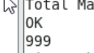

Ans 2
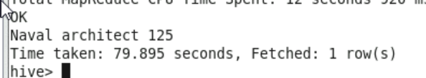

Ans 3
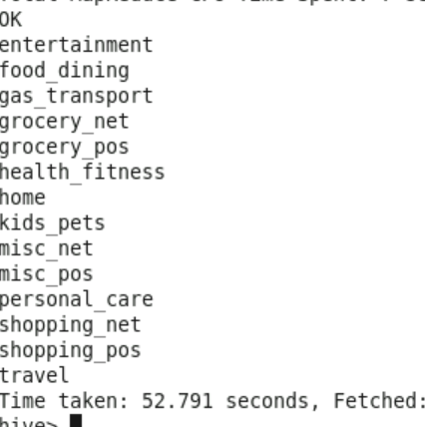

Ans 4



